The D-Team
Preliminary Design Report
ENES100
Milestone 3
10/24/2013
Section: 0401
Michael Bassett
Kushal Desai
Mike Diblasi
David Dorsey
Steve Ge
Joshua Hall
Julie Romanosky
Alexa Tsintolas
Charles Wang
Bryan Weiner

Table of Contents
Approvals………………………………………………………………………………………..3
Executive Summary………………………………………………………………..……………5
Introduction……………………………………………………………………………………..6
Preliminary Design Details……………………………………………………………………...7
Preliminary Design Drawings………………………………………………………………….15
Preliminary Bill of Materials………………………………………………………………...…17
Preliminary Gantt Chart………………………………………………………………………..18
Construction and Testing Plans………………………………………………………………...18
Anticipated Difficulties………………………………………………………………………...19
Appendix………………………………………………………………………………..……...22

Approvals
Michael Bassett- I contributed to this project as the leader of the Propulsion and Power subgroup. I calculated the flow rate, area, and thrust required for the propulsion fans in order to select the proper model of propulsion fan. I was also responsible for making sure that the propulsion fans I helped choose and the fan servo motors were ordered and shipped in a reasonable amount time so that we can prototype and test them on the hovercraft.
______________________________
Kushal Desai- I’ve contributed to the project as a member of the Sensors, Control, Programming and Payload Delivery subgroup. I helped determine the payload delivery method and the necessary sensors for payload delivery. I also helped design a whisker touch sensor system that will stop the hovercraft at the delivery box and activate the payload system.
______________________________
Mike DiBlasi- I’ve contributed to the project as a member of the Structure and Levitation subgroup. I came up with our double deck skirt attachment design. I went through all of the levitation fan calculations and helped locate a suitable levitation fan. Then, I calculated the operating point for the fan, given its fan characteristic. I also helped gather supplies for the hovercraft; I drove to Home Depot and Jo-Ann Fabric to buy foam, balsa wood, Gorilla Glue, and ripstop nylon.
______________________________
David Dorsey- I’ve contributed to the project as a member of the Structure and Levitation subgroup. I helped determine the shape of the structure and skirt design. Also, I went shopping at Home Depot and Jo-Ann Fabric to buy foam, balsa wood, Gorilla Glue, and ripstop nylon. I helped with the calculation of the mass moments of inertia of the structure and components on the hovercraft and the ordering and selection of materials.
______________________________
Steve Ge- I contributed to this project as a member of both the Sensors, Control, Programming, and Payload Delivery subgroup and the Propulsion and Power subgroup. I helped finalize the number and location of sensors and the mechanism of the payload delivery system. Also, I assisted developing the hovercraft pseudo code. Furthermore, I presented for the Sensors, Control, Programming and Payload Delivery subgroup for Milestone 2, coordinated with the Propulsion and Power subgroup to decide on how much power is need for the hovercraft, and helped draw the circuit diagram.
______________________________
Joshua Hall- As the Structure and Levitation subgroup leader, it was my job to help create the design of the deck and skirt and delegate certain jobs to Mike and David, the other subgroup members. I also drew the circuit diagram for the hovercraft and created the CAD drawing of the Payload structure. For the report, I created the Cover Page, the Table of Contents, and formatted the design drawings.
______________________________
Julie Romanosky- I have contributed to this project by creating and maintaining the Gantt chart. For the paper, I prepared the Gantt chart, the Construction and Testing Plans, as well as the Anticipated Difficulties portion. I also developed and gathered the required information for Milestone 4, due Thursday the 24th.
______________________________
Alexa Tsintolas- My main roles in this project are Notetaker and Treasurer. I created a group blog where I record what is discussed during full group meetings as well as post any other relevant files, links, and pictures. I encourage members from the various subgroups to take notes during their meetings and submit them to me so that I can post them on the blog. As Treasurer, I am in charge of collecting money for my group members to pay for the hovercraft materials, the creation of the Bill of Materials, shopping for and ordering supplies, and making sure that my group stays within the $350 budget. I went shopping at Home Depot and Jo-Ann Fabric to buy foam, balsa wood, Gorilla Glue, and ripstop nylon. I am also a member of the Sensors, Control, Programming, and Payload Delivery subgroup and Notetaker for the subgroup. I helped my subgroup determine the number and types of sensors needed for hovercraft control and payload delivery. In addition to creating the Bill of Materials for the Milestone 3 Report, I organized the Approvals section.
______________________________
Charles Wang- I contributed to this project in the Sensors, Control, Programming, and Payload Delivery subgroup. I helped determine the location and amount of sensors along with the payload delivery method. I helped develop the pseudo code for the hovercraft’s motion along the track as well as the motion for the payload delivery system. I also helped draw a circuit diagram for the sensor array going through the Arduino.
______________________________
Bryan Weiner- As project leader, my main contributions to the project consist of overseeing the project and designating specific tasks and deadlines to other group members. I make sure that all group members are on task as well as completing tasks that aren’t specific to a subgroup, such as CAD drawings, myself. I attempt to encourage a great deal of information exchange between the subgroups so that everyone in each subgroup knows exactly what is going on in the other subgroups. Additionally, I helped with the levitation fan and propulsion fan calculations, selection of the propulsion fan, creation of the hovercraft hull, and the payload delivery method.
______________________________
Executive Summary
The goal of our project is to create a hovercraft that can deliver a ping pong ball to specified location. The hovercraft must be autonomous, meaning that it runs by itself without our control. Our hovercraft will be pear shaped; we chose this design so that we could make our hovercraft as wide as possible while also cutting corners to make our weight as small as possible. The hovercraft will be made of Styrofoam and cardboard. We will also have a skirt made of rip stop nylon that will inflate with air to allow the hovercraft to levitate. The hovercraft will use one fan aimed downwards in the center of the craft to levitate, and two fans on either side to move forward. Those two fans will rotate, meaning that the hovercraft can move in either direction.
Because the hovercraft must be autonomous, we will use an Arduino Uno to control it. The Arduino will tell the hovercraft when to move forward and turn based upon a black line that runs from the start of the track to the box in which we will place the ping pong ball. The Arduino will use three sensors that measure light to tell whether the hovercraft is over the black line or not. If it is over the black line, it will continue moving forward. If it is not on the black line, it will correct itself to get back onto the line.
Once we reach the box at the end of the black line, we will use a robotic arm to drop the ping pong ball into the specified bin. The specified bin changes with each run. There is a radio frequency beacon that sends a message saying which bin the ping pong ball must be dropped into. We will attach a radio frequency receiver to our hovercraft so that it receives this message and will know which bin to drop the ping pong ball into. To hold the ping pong ball, and later drop it, we will use a robotic arm.
In addition to the listed constraints, we also need to keep the total cost of our hovercraft below $350, and the hovercraft must complete its mission in ten minutes or less.

Introduction
Our assignment for this semester is to design and engineer a hovercraft. This hovercraft must be able to autonomously follow a black line through a designated path and then correctly place a ping-pong ball into the appropriate quadrant of a pedestal at the end of said path. The additional basic requirements and restrictions are that the hovercraft must be able to levitate for at least 10 minutes, it must be built within a $350 budget, that the single payload be delivered to the correct quadrant during the mission, and that no combustion engines are used.
In its simplest form, the hull of our hovercraft consists of a pear-shaped piece of Styrofoam that is about 400mm wide and 600mm long. Attached to the edge of this hull is a sheet of rip-stop nylon that we are using as a soft skirt. There will be a single axial fan, located at the center of gravity of the hull, which will inflate the skirt and provide levitation for our hovercraft. Two ducted axial fans on either edge of the bottom circle of the pear will provide propulsion and steering for our hovercraft. We will also have a robotic, servo motor-powered arm at the top end of our hovercraft to deliver the payload.
An Arduino Uno microcontroller will be programmed to control all of these various mechanics. Two batteries will power the fans and the Arduino. For sensing its surroundings, our hovercraft will use 3 photoresistors, two contact sensors, and a radio frequency receiver. During the first part of our mission, the Arduino will be taking in information from the 3 photoresistors, aligned in an upside down triangle on the bottom of the hull, to determine when to turn while following the black line. The Arduino will know when it reaches the end of the course when the touch sensors placed at the front of the hull tell it that it has touched the pedestal. Then, the Arduino will read the radio frequency that is being sent out by the pedestal telling it which bin to place the ping-pong ball in. Once this information is known, the Arduino will maneuver the arm of the payload delivery system over the indicated bin and release the payload.

Preliminary Design Details
Hull
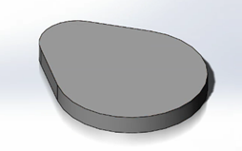
The hovercraft base has a deck structure made from Styrofoam. The design consists of two connected circles, the bigger having a diameter of .4m, and the smaller having a diameter of .2m, making the estimated area .1462m^2 (See Figure 1).This number was received directly from the Solidworks design of the deck. Styrofoam is nice because it’s a light, cheap material ($5.48 for one sheet) that can be shaped easily; the only disadvantage is that it isn’t as durable as wood. To address this, we purchased extra foam, just in case our foam is somehow damaged. The thickness of the hovercraft will be one inch. The idea of creating the structure in this shape allowed us to place the fans on the outside of the bigger circle creating enough torque to turn while reducing the area of the body. You may ask why have a pear shape when you can generate the same amount of torque using a rectangle or circle with another design. The difference between our design and a rectangular design is that we are eliminating the extra area used in the other designs while generating the same amount of torque with a smaller mass. Having a smaller area allows our levitation fan to operate more effective, this will be better explained in the levitation section. We estimated the mass of our hovercraft to be 2.4 kg. This is only an estimate, and the hovercraft may end up having a higher mass than expected. To counter this, we purchased levitation and propulsion fans that are stronger than we actually needed. We selected fans that would operate in a favorable range if our hovercraft weighed 2.4 kg or more.
Our design is rather oddly shaped. However, it still has one major line of symmetry, and we believe that manipulating the center of mass should not be too difficult. We would like the center of mass for our vehicle to be directly in the center of the levitation fan, which will be placed at the center of the design. This is located 232.08 mm from the base and symmetrically distanced from the left and right edge. One component that may make it difficult to control the center of mass is the payload arm that sits on the very top of the pear. However, we should be able to use a ballast or counterweight it to make up for this. The front of the pear will be used to hold our payload delivery system of a robotic arm controlled by servos and the Arduino Uno microcontroller. To support our hovercraft’s skirt system we will use a double deck design. A cardboard piece will be placed under the hovercraft separated by support beams. Then, using gorilla glue and possibly other adhesives such as duct tape, our ripstop nylon skirt will be attached to the lower deck and the upper deck. This secures the skirt onto the structure and creates steady airflow up to the hovercraft allowing levitation.
Figure 1
Below, in Table 1, we have calculated the moments of inertia for the major components of our hovercraft.

Masses and Mass Center of Inertia for Parts
Component | Moment of Inertia (kg(m^2))
Levitation Fan and Guard | 3*10^-3
Propulsion Fan | 1.1*10^-3
Arduino Uno and Sidekick Kit | 8.1*10^-4
Foam Base and Skirt | 7.1*10^-3
Payload Arm | 1*10^-2
12V battery | 3.9*10^-3
Total | 2.6*10^-2

Table 1
Payload Delivery
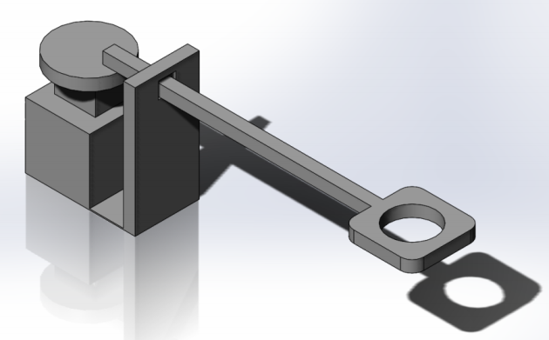
For the payload delivery, we designed a device that consists of a rod mounted on a single disk being spun by a servo motor. This rod, oriented tangential to the plane of the disk, is mounted on a hinge to let it freely rotate as the disk rotates under it. This rod will also be going through a stationary holster at the front of our craft to stop that point of the rod from moving but allow the rod to slide forward and backwards within it. As the disk that the rod is hinged to rotates, the angle the rod makes with the holster will change and the length of the rod that is sticking out from the front of our hovercraft will change. With the right calculations, we determined that by rotating the disk, we could get the other end of this rod to move over all four quadrants of the bin that will be in front of our hovercraft at the end of the course. To see a drawing of this design, please see Appendix 3. This design is ideal because, unlike our first robotic claw design that required three servo motors, this design only requires one to rotate the disk and one to release the ping pong ball. Additionally, we can make sure the ball doesn’t bounce out of the bin it is dropped in with this system because the arm stays at a constant height. This is also lighter design that also is much easier to program for. The servo motor that will be spinning the disk will be placed on top of a styrofoam block to allow the arm of the system to reach over the top of the box. The bottom of the arm will rest upon the top of the disk 80mm above the base of our hovercraft and will be hinged 26mm out from the axis that the disk is rotating on. The radius of the disk will be 30mm and the axis of the disk will be 85mm from the edge of the hovercraft where the holster will be located. At 80mm above the edge of our disk, a holster will be located to allow the arm to slide through. This arm will be about 280mm long and contain a cylinder like shape at the end for the ping pong ball. A string will be attached to a piece holding the ball place and, when our hovercraft is in position, a servo motor will pull the string to release the ping pong ball. Overall, this is an extremely efficient mechanism and as long as we can get the complex pieces working, it will play a key role in our hovercraft’s success.
Figure 2

Levitation
When designing the lift system for a hovercraft there are two factors that play a major role: plenum pressure and flow rate. The vehicle needs a certain amount of plenum pressure in order to levitate. With this pressure calculation, a flow rate can be determined that is required to reach a desired hover height.
The plenum pressure can be determined by utilizing Newton’s second law of motion. Newton’s second law states that the acceleration of a body is directly proportional to, and in the same direction as, the net force acting on the body, and inversely proportional to its mass. To have a hovercraft effectively levitate the acceleration in the vertical direction must equal zero. This means the net forces acting on the body, in the vertical direction, must balance. Therefore Fp = W, where Fp can be rewritten as the plenum pressure times the plenum area and W is the mass times gravitational acceleration. With a predetermined mass and area, the plenum pressure can be calculated.
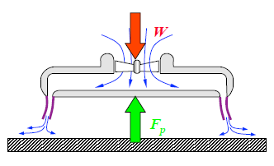
The pear shape design, previously stated in Hull Structure, has a plenum area of .1462 m^2. It was also estimated to have a mass of 2.4Kg, which was given a 20% safety net due to miscellaneous components. These two variables produce a required plenum pressure of 160 Pa.
Figure 3
The pressure build up underneath the hovercraft also forces air out. This creates a gap between the perimeter of the skirt and the ground. The hovercraft is most effective between hover heights of about 1 to 3 mm. With a desired hover height and the equation to the left, the required flow rate can be determined.
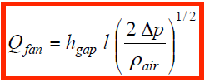
A flow rate of 82.2 meters cubed per hour is required for a desired of hover height of one millimeter. This was calculated given the perimeter of our vehicle is 1.393 m and the plenum pressure necessary to levitate is 160 Pa.
Figure 4
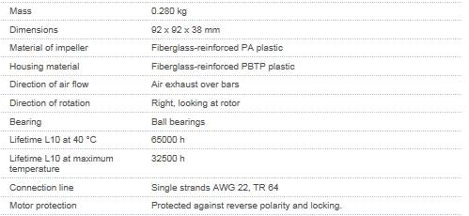
Having calculated the two primary factors necessary to ensure our vehicle would levitate and hover at an effective height, we began looking for a single fan that would work specifically for our vehicle. The two types of fans that we discussed utilizing included centrifugal and axial fans. Both of these fans had positive and negative aspects. We almost immediately turned down the idea of a centrifugal fan due to its small flow rate and larger size. We looked at a dual compact axial fan as the most effective possibility due to its counter rotating abilities. The number one draw back when looking at a axial fan was this rotation problem. Unfortunately we could not locate a dual compact fan that was effective, under budget, and available for purchase. This brings us to the fan we chose, the 3212 JH 3 DC axial compact fan.
Figure 5
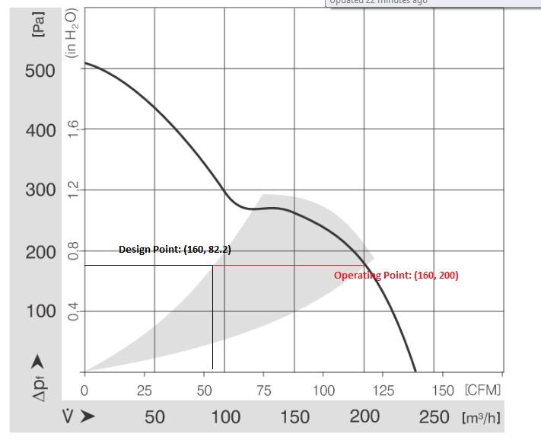
In Figure 5, you can see it is a single axial fan made of fiberglass-reinforced PA plastic. The mass of fan will be about .3 Kg, considering the addition of a fanguard. As you can see the dimensions of the fan are listed to be 90x90x38mm with a diameter of 98mm. The price of $60.78 is very cheap in relation to the other dual compact fans and will keep us under budget. We feel the rotation problem can be solved with proper skirt construction due to frictional force as well as strategically placed support bars.
The fan characteristic curve (Figure 6) displays change in pressure (Pa) vs air flow (m^3/hour). The fans most effective operating region is shown by the grey portion. As you can see our design point of 160 pascals and 82.2 meters cubed per an hour exists well below the curve. This is where we want to be, but the actual operating point of the fan must lie on the curve. (This is shown to the right in red)
Figure 6
Most importantly, the operating point lies in the grey portion of the fan characteristic. This changes the actual hover height to 2.41mm, which is still within the effective range of 1 - 3 mm. This value is not foolproof because our double deck construction allows us to reduce the plenum area slightly. A reduction of area would increase the pressure necessary to levitate. You can visualize an increase in pressure would bring the operating point higher up the curve thus reducing the flow rate. A smaller flow rate and higher pressure would bring us closer to our desired hover height of 1 mm.

Propulsion
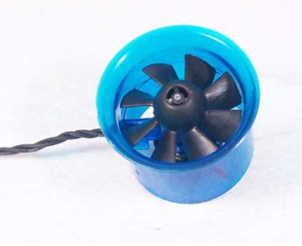
The original idea we had was to have two fans on either side of our pear shaped structure. From the beginning, we had two options in choices of fans. The first option was putting the fan on a servo motor so the fan could rotate. The other option was to have a fan that could reverse polarity. This would allow the fan to stay stationary and we could reverse the directions in order to slow down the hovercraft to increase portability and control of the hovercraft. We discussed this on our first and second meeting arguing between the two options and finally decided on reverse polarity fans. We thought that the pear shape would allow us to extend the propulsion fans far enough horizontally to allow easier turning. After figuring out this we began the searching for the right fan. Using Newton’s Second Law, we solved for the necessary thrust for each fan. After getting the thrust we found the airflow of the fan based on the thrust equation that was given to us in class. We had great troubles figuring out the exact numbers we needed because our originally the numbers we were finding for our airflow was way too high to be plausible. It took us a week or two to figure out the exact problem. We diagnosed the problem and moved on to finding the proper fan. When searching for the proper polarity fan, we ran into a problem. There were very few reverse polarity propulsion fans that were strong enough to generate the required thrust. The only ones that had the necessary airflow to move the hovercraft weighed at the higher end of .6-.9 kg. This weight would have changed our mass to a much greater mass increasing airflow those not allowing us even to use those. We learned of this problem a few days ago causing our sub group to have to meet on Sunday and Monday to find a new propulsion fan and discuss what we could do next. We had two more options. It was either go back to the first plan, which would have been more difficult to construct and control. The other option that we faced was double the fans and put them in parallel in order to increase the airflow by doubling the amount of fans we have on the device. We were stuck. We couldn’t find a new fan and didn’t know where to turn. We decided that we should go and talk with Judy, the TA, in order to figure out if we calculated something wrong. She gave us some recommendations for types of fans and ideas of how to operate the fans. The final idea has come down to us getting two lightweight servo motors that will turn the fans going back to one of our first ideas. This will be good because we found multiple fans that fit our requirements of about 58 mm in diameter. We decided against this design as well because there would be too much weight allotted to the propulsion fans that could be better used for other parts such as the batteries or unaccounted weight. After much debate and much discussion we finally found a fan that fit our requirements. We chose the blue fan shown in Figure 7 which generates a thrust of 122 grams when operated at 12.3 A. Though the fan is a little stronger than what we had in mind, it appears that our mass estimate may be too low, so the extra strength from this fan may be needed. The fan is small, with a diameter of 30 millimeters, and was relatively cheap compared to other fans. Because this fan is brushless, meaning it cannot change direction, we will place it on a servo motor, which will allow it to rotate.
Figure 7

Power
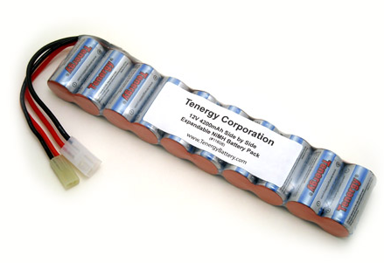
The hardest challenge when it comes to powering the hovercraft is finding a battery that is strong enough to power the levitation and propulsion fans for ten minutes. This requires not only a high voltage but also a very high current draw. Originally, we had chosen a 700 mAh battery, believing that it would be able to power these three fans for ten minutes. However, after reconsidering our circuits and receiving feedback from our presentation, we realized that this is an inadequate battery. As a result we began to look into finding a new battery, one that can supply more amperes per hour. Our new battery is a 12V Nickel Cadmium battery that supplies 4200 mAh. Its model number is 11608. It is shown in Figure 8. We have decided to use this battery to power the levitation fan, the propulsion fans and the two servo motors attached to the propulsion fans. This battery will not be connected directly to the Arduino. However, the Arduino will be able to control each of these components with the use of a transistor.
Figure 8
The Arduino will be powered by a 9V alkaline battery. The Arduino will dissipate power to the three photosensors, the radio frequency receiver, and the servo motors that power the payload system. Originally, we were trying to find a larger battery, but we believe that this battery will be adequate enough to power those components. Also, because there is no charging time associated with it, we will be able to have a fresh battery on demand, assuming that we keep a good stock of these batteries.

Sensors and Actuators
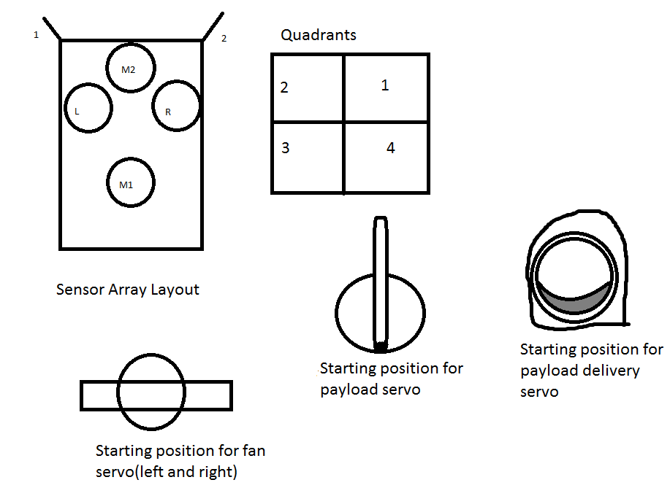
The hovercraft will have six on-board sensors to aid in its control in navigating the course and completing the objective. There are four photoresistors to follow the black line on the course, and there are two touch “whiskers” that ensure that the hovercraft has made contact with the platform and that payload delivery can begin. The photoresistors are positioned under the skirt so that two are in the middle on the black line, and two are on opposite sides of the black line, barely touching the line. The thrust fans are on servos that can move independently to provide a small turning radius. Also, the payload mechanism is controlled by two servos, one rotating the disk, and the other acting as the claw to release the ball when appropriate. A drawing to better exemplify the positioning of the sensors and explain the servos in relation to the code is provided in Figure 9.
Figure 9
Control Algorithm
The hovercraft first determines if the whiskers have made made contact. In order to qualify for contact, both sensors 1 and 2 must be activated. If not, it follows through the move methods using the photoresistors (M1, L, R, M2) as guides.
The levitation fan is always on and its operation is not altered by the sensors. In order to move forward initially, M1 must read black and sensors L,R must read white. To move forward, the fan servos are not rotated and power is given to the thrust fans. If M2 reads white and R reads black, the hovercraft moves right to follow the line. To turn right, the right fan servo rotates 180 degrees and power is given to both thrust fans. If M2 reads white and L reads black, the hovercraft moves left to follow the line. To turn left, the left fan servo rotates 180 degrees and power is given to both thrust fans.
At the beginning of the forward motion method, the fan servos are assigned back to 0°, or the starting position described in the previous drawing. If a move method is not called, the thrust fans are not activated.
Once the hovercraft has reached the platform and the touch sensors have both been activated, the payload delivery method is invoked. The radio frequency reader first reads the output from the platform, and assigns that to the quadrants in the drawing above. Next, the payload servo rotates the given amount and then releases the payload using the payload delivery servo. At this point, the payload will be delivered and the mission will end. Pseudo code to better exemplify the functions of the sensors to control the servos in relation to the methods has been provided. Please see the pseudo code in Appendix 1.
Preliminary Design Drawings:
Here is a drawing of the hovercraft with each component’s distance to the center of mass labeled.
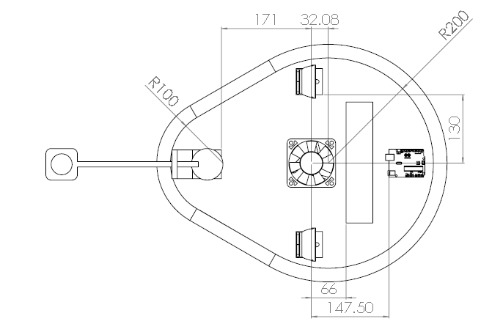
Arduino
Battery
Levitation Fan
Right Propulsion
Left Propulsion
Payload Arm
Figure 10

Below is an isometric view of the fully assembled hovercraft: 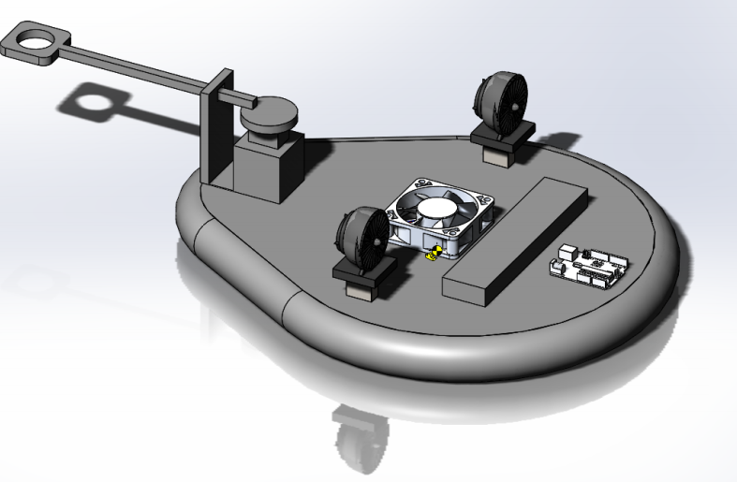
Figure 11
Here is a 3-view drawing of our hovercraft:
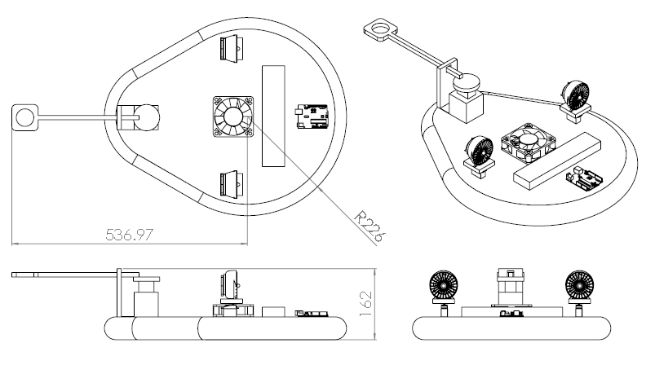
Figure 13
Below is our Wiring Schematic:
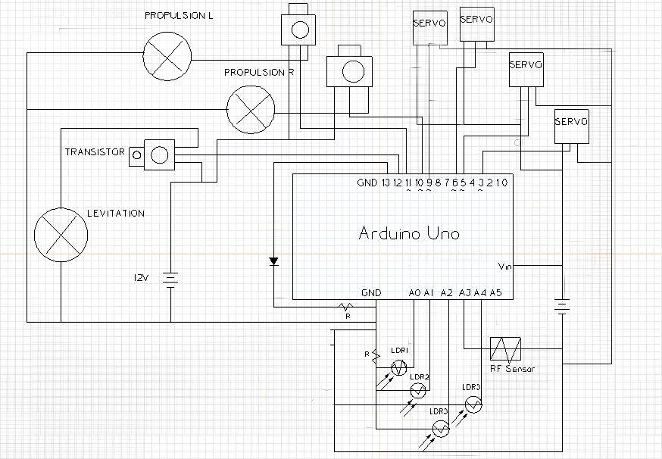
Figure 14

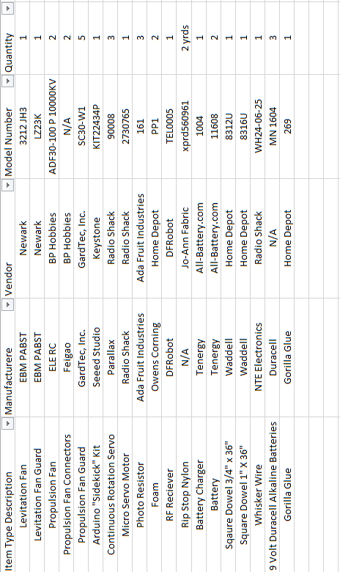
Bill of Materials Part 1

Table 2

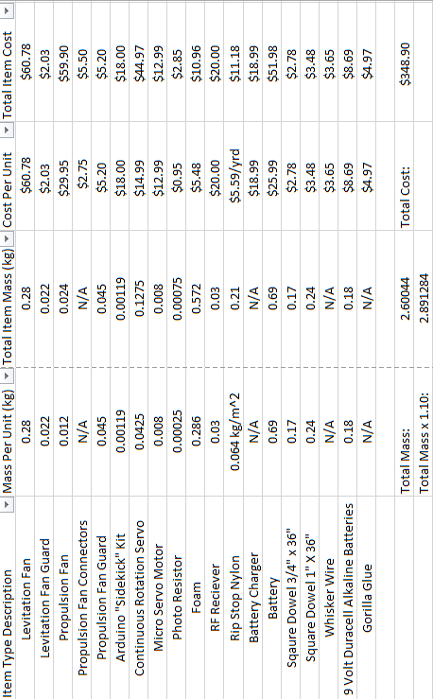
Bill of Materials Part 2

Table 3

Preliminary Gantt Chart:
Please see page ___ in the Appendix to see the complete Gantt chart.

Construction and Testing Plans:
As of October 21st, there are several tasks on our Gantt chart that have not been completed yet but have been started. Both determining adhesive and building methods and final bill of materials have been started however we have not finished them. While we have a basic idea of how we will manufacture the components of our craft, we have not yet gotten a sample of our deck material to test any type of adhesives out on yet. This testing would ensure we do not use an adhesive that is not reactive or corrosive to our other materials. Our bill of materials is also not yet complete due to our group falling behind in certain areas such as the payload components or determining the necessary electrical components needed for our circuit. The last major area we have started but are behind on is purchasing our materials. This is because we do not have a clear bill of materials to work from and have been having trouble determining exactly what our hovercrafts various systems require. This is due to our uncertainty in our calculations for fan requirements, weight, and other forces that could be acting on the hovercraft.
In order to make up for these uncompleted tasks we have required all members to attend a mandatory group meeting where these issues will be addressed. The meeting will not adjourn till all issues surrounding upcoming or current tasks, Gantt chart deadlines, or Milestones have been resolved with confidence. We hope that this will set us back on track to complete the project with accuracy and quality and prevent future issues from going unaddressed till they’re out of hand.
Currently our only upcoming uncompleted tasks are to begin building our hovercraft parts (See Appendix 2). The building stage is scheduled to start Thursday October 24th after we turn in our Milestone 3 and Milestone 4 reports and should last till about November 7th. This allows us a cushion of time before we must perform testing at Milestone 5 on November 14th. During the time leading up to Milestone 5 we plan to design and execute preliminary tests of our own to make sure we will be ready to officially test on November 14th. After our personal testing we will then make any necessary repairs or adjustments to our hovercraft. The budgeted time cushion allows for these steps and will hopefully ensure that our craft performs well when testing at Milestone 5 while also providing room for any delays in construction or material procurement.

Anticipated Difficulties
As with any project there are many aspects that could potentially cause issues during any part of the design process. One of our primary concerns is our battery. We must chose a battery that not only supplies the correct voltage and current for the circuit but also provides enough run-time to complete our testing at Milestone 5. Originally our selected battery would only be able to run our circuit for about 10 minutes. This was a problem because we need a minimum of 10 minutes for the testing alone. We ended up replacing this battery and buying two of the new ones to help increase our run time. Although we aren’t anticipating running all fans and servo motors at full power for the entire time the hovercraft is on, we are still worried that our batteries will not provide the required charge for an optimal time.
Another set of difficulties we foresee is dealing with the payload system. We must ensure alignment of the hovercraft to the delivery site, execute a flawless code to deliver the ball to the appropriate site, and also consider how our mass moment of inertia will change as the payload system moves to deliver the ball. In order to overcome theses issues we have redesigned our payload system. The new design reduces the change in mass moment of inertia and will therefore reduce the pushback on the craft as the arm moves out to deliver the ball. This will also help to keep the craft in place.
In order for our craft to be successful we must first have a perfect code for our craft to execute. Without this the hovercraft will not know where it is, how to navigate to the delivery site, or how to correct itself it a problem arrises. To avoid having our craft fail we will designate extra time to developing the code and troubleshooting any errors, this extra time has already been accounted for in Gantt chart in Appendix 2.
The final set of difficulties we expect are structurally based. First, we must try to fully balance the hovercraft’s mass moment of inertia and center of gravity. This can be difficult and if not properly balanced the unbalanced portion will create a moment on the craft, making it spin and unable to control. To counteract this we will place weights on our completed craft as needed to balance and attempt to “zero out” our moments and weight.
Perhaps the biggest anticipated difficulty is in the estimations we used to perform our calculations. These estimations played a key part in finding our fan requirements which are at the heart of our craft being able to even act like a hovercraft. If our estimations are too far off from our real values then our fans may no longer be adequate for our craft. In order to avoid this we used estimates that would require us to get fans and motors with capabilities that are beyond what we estimated our hovercraft would need.

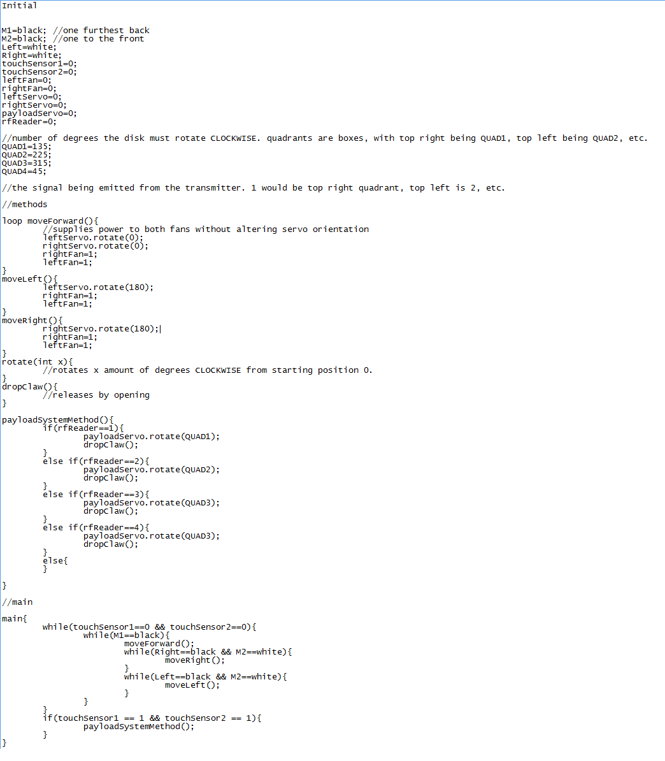
1)
Appendix
2)
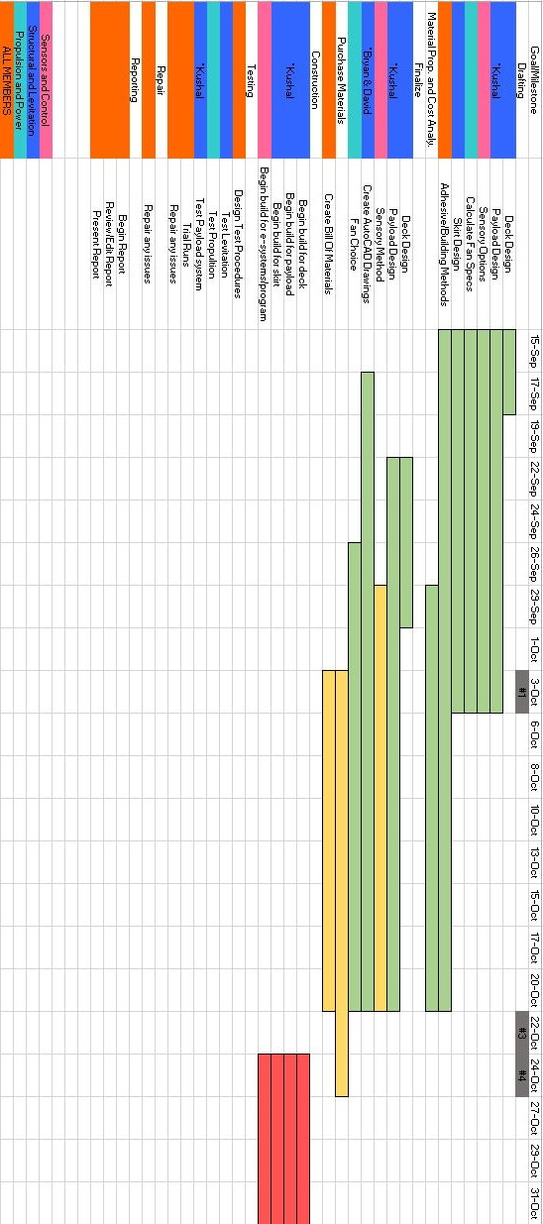

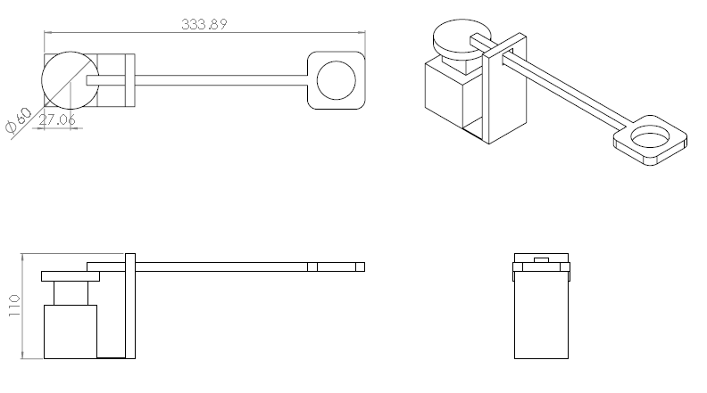
3)

